Prior Learning and Laboratory Preparation:

Complete the 3-part webinar sequence on WSM Assessment: WSM Modules 4, 5 and 6. https://www.anptsynapsecenter.com/public/page-courses/

View 3 WHO Intermediate WSTP videos

09 Hand Simulation Demonstrations for Deepak 09 (1:41 min)

10 Hand Simulation Enith 10 (2:29 min)

11 Hand Simulation Bahati 11 (2:08 min)

View WHO Basic WSTP video

11 Measurement Demonstration video. (2:38 min)

Objectives of This Assignment:
- Demonstrate how to use your hands (hand simulation) to find a wheelchair user’s optimal sitting posture.
- Identify through hand simulation the type/amount/location of support needed and document findings.
- Explain the purpose of taking body measurements.
- Demonstrate how to choose the measurements needed to select the correct size and location of postural support devices.
- Demonstrate taking and recording the basic body measurements needed for selecting seating and wheelchairs.

Materials:
1) Mat Table or Firm Surface, 2) Patient Measurement Form (pages 7-9), 3) Metal Tape Measure, Goniometer, and Calipers (if available) - 1 for each group

Laboratory Assignment:
You and your lab partner will practice your wheelchair assessment skills of hand simulation and body measurements.
Like the previous lab, you and your lab partner will take turns being the ‘clinician’ and the ‘patient’.
- Patient: develop a NEW patient/wheelchair user profile for a person with basic to intermediate postural support needs when sitting on a mat (“hands dependent” or “prop-sitter”). Enter the information describing the characteristics of the person that you will portray for your lab partner on your assignment form (Wheelchair User Profile) on page 7, including:
  - Demographics: (age, gender, diagnosis)
  - Describe each postural deformity and whether it is fixed, flexible or mixed: scoliosis, pelvic obliquity, pelvic rotation, pelvic tilt, excessive kyphosis, excessive lordosis, etc.
  - ROM limitations: degrees of ROM, side (right, left, bilateral), joint (hips, knees, ankles),
  - Neuro considerations (tone, spasticity, reflexes)
  - Other
- Clinician: follow the activity instructions detailed below and complete the Wheelchair Assessment: Simulation and Body Measurement form on pages 8 – 11.

Background: After the physical assessment of ROM and postural alignment, the clinician completes the wheelchair assessment including simulation, measurements of the wheelchair user, technology trial and identifying the person/technology match.
In WSM modules 4, 5 and 6 we discussed components of the WSM Examination and Specialty Evaluation. The WSM Physical Assessment; Mat Assessment and Postural Alignment Lab focused on the mat assessment, specifically assessing ROM and postural alignment to identify a wheelchair users’ ‘optimal sitting posture’.

This lab focuses on the hand simulation and body measurement portion of the wheelchair assessment.

Each person’s optimal sitting posture is unique. The only way to identify this posture is to take time out of the wheelchair, on a firm seated surface and help the person move in and out of different positions in order to find the posture where he or she is most functional, comfortable and balanced.

How do we know when we have reached the person’s optimal sitting posture?
- The pelvis, hips and legs are supported taking into account available flexibility, and influence of tonal patterns.
- The head is balanced over the pelvis, such that the person feels balanced and calm. Often the person takes a deep breath.

Instructions:

PART 1: Simulation:

  - Using the skills you practiced in the Mat Assessment and Postural Alignment Lab determine if the wheelchair user can sit in a neutral sitting posture with support? If not- how close to neutral can they sit?
    - Begin with the person sitting on a firm surface with lower body support. If needed, supports can be used to position the wheelchair user’s feet at the correct height so the upper legs are parallel to the seating.
    - Always provide support at the pelvis first. This is because the posture of the pelvis will affect the rest of the body.
    - If the wheelchair user’s pelvis is not in neutral, use your hands to encourage the pelvis towards neutral.
    - When the pelvis has been supported, focus on other parts of the body in this order: trunk/arms; head and neck; hips and thighs; lower legs.
    - Always make only one change at a time. For example- do not try to change the posture of the trunk at the same time as changing the posture of the pelvis.
    - Work with an assistant (this can be a family member or caregiver).
    - Observe how changes in one part of the body affect other parts.
    - Ask for feedback from the wheelchair user.
    - Observe the contour of the pelvis and trunk from the side. This is important to help plan the needed backrest shape that can provide the best support.

  - Identify what support is needed. Note type/amount/location of support needed and document findings on the lab sheet.

  - When the optimal posture is found, take a photo from the side and front.

  - Record your hand simulation findings. On the lab form describe and justify the postural support features needed for seating.

    - Indicate whether the wheelchair user can achieve a neutral sitting posture for each body part with external therapist/clinician hand support;

    - Describe or line draw the final (best) sitting posture achieved by the wheelchair user with the hand support: and

    - Describe or line draw the support needed in a wheelchair system for the wheelchair user to achieve optimal sitting posture.

PART 2: Body Measurements

During the Wheelchair Assessment portion of the WSM evaluation, anatomical measurements of the wheelchair user are taken and recorded.
Measuring Tools
- Use a retractable metal tape measure
- Clipboards/books can be used to help measure accurately.
- Large callipers are an additional tool that can be very useful.
- Supports can be used to position the wheelchair user’s feet at the correct height.
How to Measure: In the U.S. measurements are taken in inches.
- For all measurements, make sure the tape measure is held straight.
- Always measure a wheelchair user in sitting, and in the posture that has been identified as the most upright, comfortable and functional for them during the hand simulation.
- When measuring a person who has difficulty sitting upright, assistance may be needed.
- The feet should be supported on the floor or on supports if they cannot reach the floor comfortably.
- Holding a clipboard/book on either side of the wheelchair user can help in obtaining an accurate measurement.
- Bend down to ensure you are viewing the tape measure at the correct angle.
- When taking body measurements, the “seat” is the surface on which the pelvis is sitting.
- For all vertical measurements – the location of the corresponding component will be affected by any changes to the seat and cushion height.
- The exact fit and location of all wheelchair components is always checked at the final fitting.
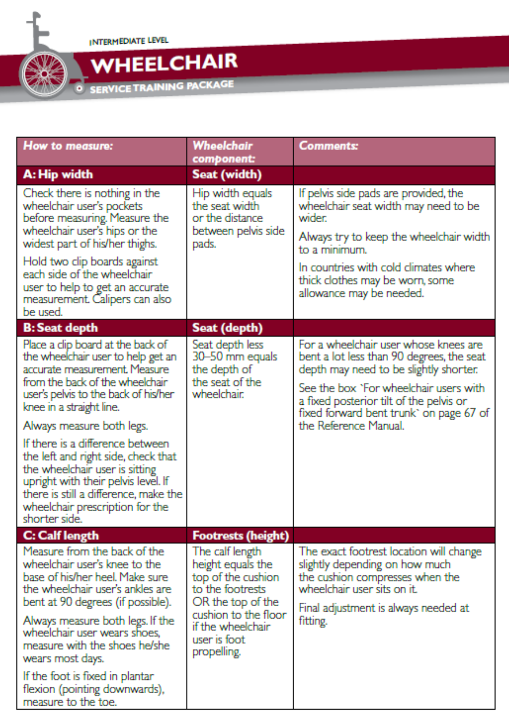
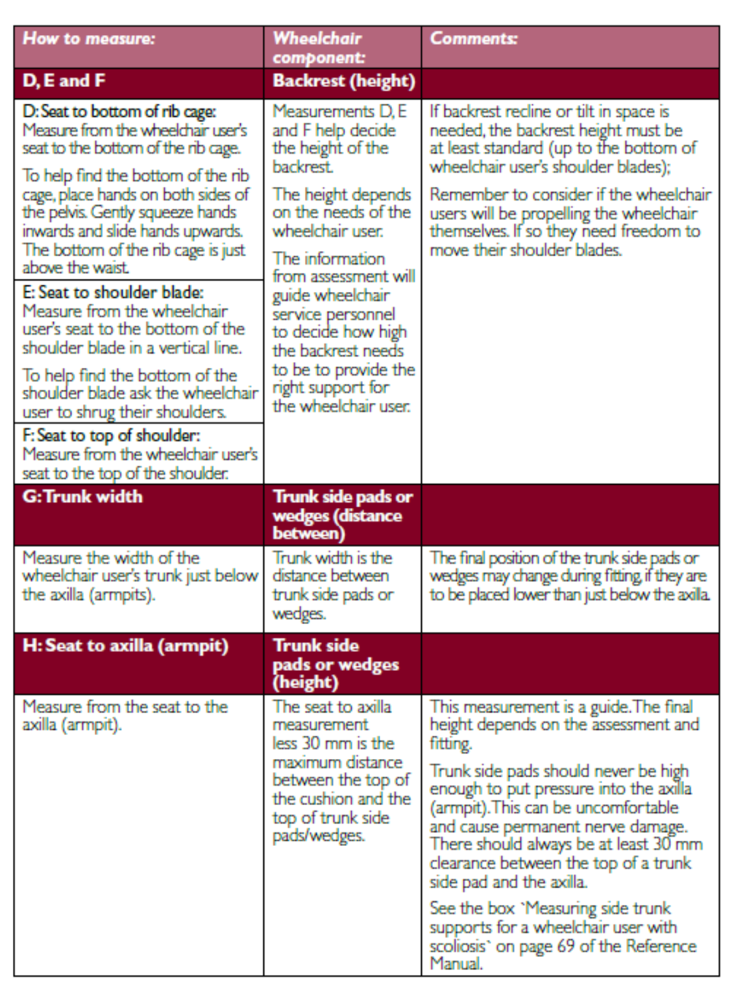
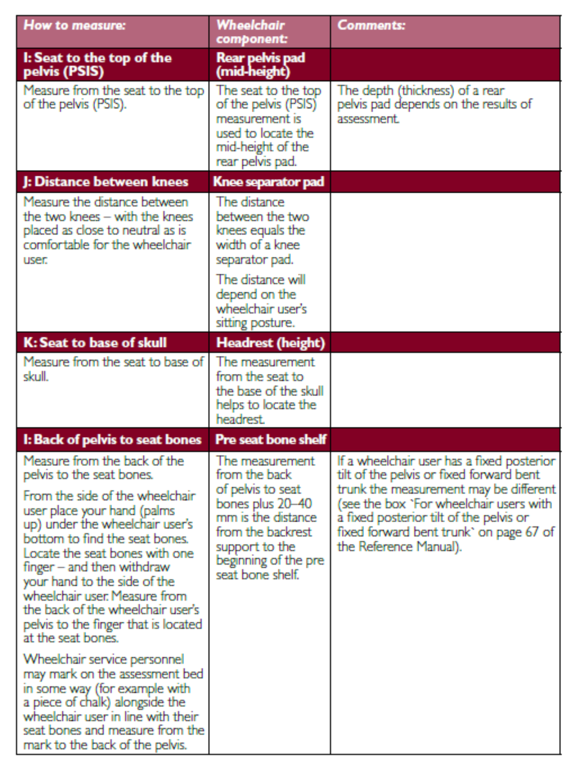

ASSIGNMENT

Wheelchair User Profile (to be filled out by the “patient”):

Describe the characteristics of the patient/wheelchair user that you will use for your lab partner.

- Demographics (age, gender, diagnosis)

- Describe each postural deformity and whether it is fixed, flexible or mixed: scoliosis, pelvic obliquity, pelvic rotation, pelvic tilt, excessive kyphosis, excessive lordosis, etc.

- ROM limitations: degrees of ROM, side (right, left, bilateral), joint (hip, knees, ankles)

- Neuro considerations (tone, spasticity, reflexes)

- Other

Wheelchair Assessment: Simulation and Body Measurement (to be filled out by the “clinician”):

- Using the skills you practiced in the Mat Assessment & Postural Alignment Lab determine if the wheelchair user can sit in a neutral sitting posture with support? If not- describe how close to neutral they can sit?

- What support is needed and where? Note type/amount/location of support needed.

- When the optimal posture is found, take a photo from the side and front. (insert here)

- Record your simulation findings and the postural support features needed for seating.
  - Indicate whether the wheelchair user can achieve a neutral sitting posture for each body part with hand support;

  - Describe or line draw the final (best) sitting posture that can be achieved by the wheelchair user with the hand support: and

  - Describe or line draw the support needed for the wheelchair user to achieve their best sitting posture.

- Describe and justify the postural support features needed to achieve the identified seating posture.

PART 2: Basic Body Measurements:

Record the body measurements of your partner.
