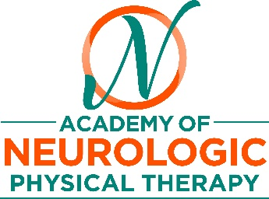

**References:**

1. Retrieved from (www.cdc.gov/traumaticbraininjury/index, 2018)

# Silverberg ND, Iverson GL. Is rest after concussion "the best medicine?": recommendations for activity resumption following concussion in athletes, civilians, and military service members. J Head Trauma Rehabil 2013 Jul-Aug 28(4):250-9

# Leddy JJ et al. Rehabilitation of concussion and post-concussive syndrome. Sports health 2012 March 4(2):147-154

1. McCarty CA et al. Collaborative care for adolescents with persistent post concussive symptoms: a randomized controlled trial. Pediatrics 2016: 138
2. Thomas DG et al. Benefits of strict rest after acute concussion: a randomized controlled trial. Pediatrics 2015 January 135(2):1-13
3. McCrory P et al. Consensus statement on concussion in sport-the 5th international conference on concussion in sport held in Berlin October 2016. BrJSports Med 2017 Jun;51(11):838-847
4. Retrieved from <http://concussionsontario.org/resources/adult-concussion-guidelines/>
5. Lennon A, Hugentobler J, Sroka MC et al. An exploration of the impact of initial timing of physical therapy on safety and outcomes after concussion in adolescents. *J Neurol Phys Ther.* 2018;42(3):123-131
6. Teel E et al Predicting Recovery pattern after sport-related concussion Journal of Athletic Trainiing 7:2017: 5(3)

**Concussion**

**Authors: Mary Beth A. Osborne PT, DPT, Board Certified Specialist in Neurologic Physical Therapy**

**Karen L. McCulloch PT, PhD, Board Certified Clinical Specialist in Neurologic Physical Therapy**

**Produced by**

**Fact Sheet**

**A Special Interest Group of**

**Contact us:**

ANPT

5841 Cedar Lake Rd S.

Ste 204

Minneapolis, MN 55416

Phone: 952.646.2038

Fax: 952.545.6073

info@neuropt.org

www.neuropt.org

a component of