Title and Focus of Activity: Spinal Cord Injury Lesions Linking foundational and clinical sciences

Contributor(s): Michael McKeough, PT, EdD; mmckeough@csus.edu California State University Sacramento, Department of Physical Therapy

Course Information: Neuroscience, adjunctive learning activity within a neuroscience course

Learning Experience Description: This patient case-based learning activity is intended as adjunct to lecture on the anatomy/physiology/pathophysiology of spinal cord injury. Its advantage is that it parallels the clinical reasoning involved in examining the effects of lesions of the spinal cord, i.e., it presents simultaneously and in parallel both the behavioral level (clinical presentation) and anatomical level information about lesions of the major functional systems in the spinal cord (lateral corticospinal tract, dorsal column-medial lemniscal system, lateral spinothalamic tract, transverse cord, hemicord, central, anterior, and posterior cord lesions). It contains 9 interactive lesion lessons and 3 patient cases with feedback. It utilizes computer animation to show the injury occurring (scalpel), the neuroanatomy affected, and the clinical impairment’s presented by the patient.
Please see the PowerPoint file entitled Spinal Cord Injury Lesions. Below are screen shots from relevant content.
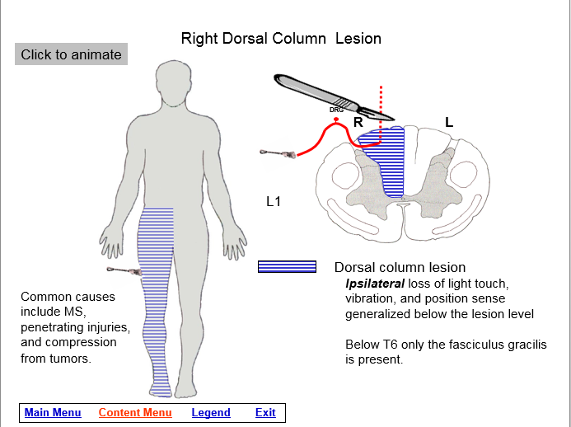
Screen shot showing diagram of lesion and question about clinical impairment. “Click for answer” reveals Example of neuroanatomical and
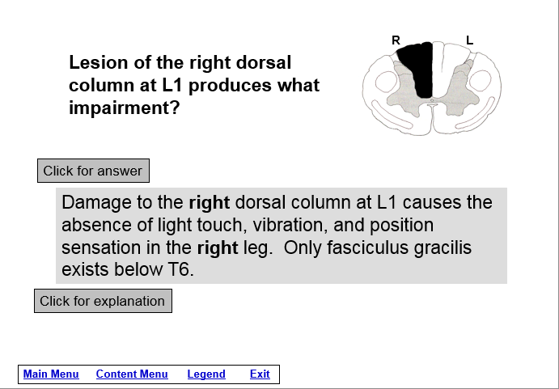
the answer. “Click for explanation” behavioral explanations. “Click to animate”
reveals behavioral and neuroanatomical produces, 1) scalpel causing the lesion, 2) brush showing
explanations (next screen). clinical test, 3) first-order neuron interrupted by lesion,
4) shaded area indicating area of damage and
clinical presentation of impairment.
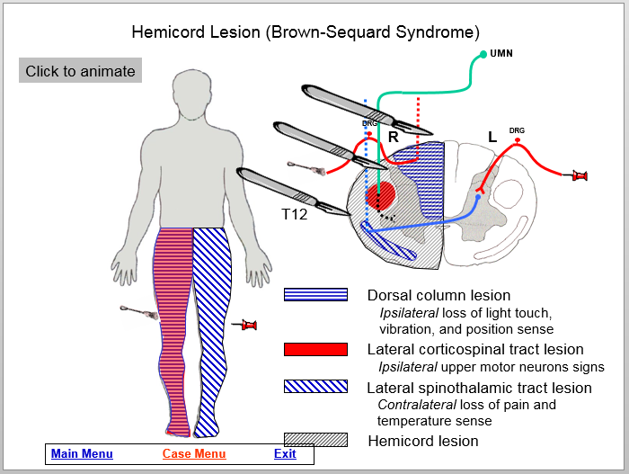
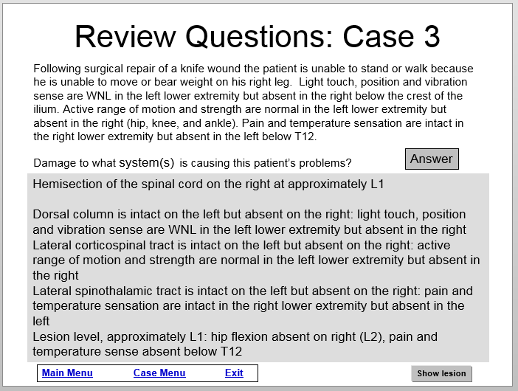
Screen shot of patient case asking damage Screen shot of lesion. “Click to animate”
to what structures cause the patient’s produces, 1) scalpel damaging each system
symptoms. Clicking “Answer” reveals answer. Individually, 2) neuroanatomy of each system
Clicking “Show lesion” reveals next screen. 4) shaded area indicating area of damage
and clinical presentation of impairment.

Time for student to complete the activity: 1. preparation for activity outside of/before class: 1-3 hours 2. class time completion of the activity: NA

Readings/other preparatory materials: Knowledge of the anatomy, physiology, pathophysiology, and clinical presentation of damage to the major functional systems in the spinal cord.

Learning Objectives: 1. Describe the signs and symptoms caused by a lesion of the spinal cord (fasciculus gracilis and fasciculus cuneatus, lateral corticospinal tract, and lateral spinothalamic tract). 2. Given a patient case (examination results and chief complaint), identify the functional systems causing the sensory and motor impairments. 3. Correlate neurology information between the behavioral and neuroanatomical levels.

Methods of evaluation of student learning: Traditional written exams that cover this and similar material.
In previous research, this module, as a stand-alone activity not coupled with lecture on the same material, demonstrated the ability to significantly increase student knowledge about the anatomy and clinical effects of lesions of the spinal cord.¹
¹McKeough, DM; Drumheller N, Gardner E, Barakatt, ET. The effects of a computer-based learning module on students’ knowledge of spinal cord lesions. Poster Presentation. Annual Conference of the California Physical Therapy Association, 2013.

