Title and Focus of Activity: Intervention for the Shoulder Following Stroke
Movement Analysis/Intervention Innovation

Contributor(s): Kristin DeMars, PT, DPT, NCS; kristin.demars@csulb.edu
California State University, Long Beach (CSULB) Department of Physical Therapy

Course Information: Advanced Management of the Individual with Neuromuscular Disorder; 1 unit; Fall semester of 3rd year. This is the last didactic semester prior to terminal internships. Students have had previous courses in Neurologic examination, Intervention for the patient with CNS pathology, and Intervention for the patient with PNS pathology. Students have had 2 lectures and 2 labs for Upper Extremity (UE) Intervention in the CNS Intervention course. Students have had 2 labs on orthopedic management of the UE following stroke in the current course prior to the assignment.

Learning Activity Description:
Students complete a laboratory on the UE post-stroke that focuses on identification and intervention of orthopedic soft tissue and joint restrictions. Students are then required to examine the shoulder of a clinic volunteer who has an impaired UE following stroke. Students work in groups of 3, and are assigned to a clinic volunteer who has an impaired UE due to a stroke. The average class size is 33, which necessitates 11 clinic volunteers. Students are scheduled to work with their clinic volunteer during our pro-bono neurologic clinic, which is being run by students in the second year cohort. The instructor supervises no more than 2-3 groups at a time over a course of 3 days.

Students are required to complete an objective examination including measurement of impairments, and use of the iPad Simi Move App to analyze functional movement (first 45 min). Departmental iPads are provided to the students. After completing the examination, students develop and implement an intervention plan that is required to address at least 2 orthopedic restrictions and 1 activity to retrain functional movement (45 minutes). They are also required to give the client a home program (final 15 min). In the following class session they present their movement analysis using Simi Move App and summarize their experience and present their results to the class in a powerpoint format.

Students are expected to complete the following worksheet:

Evaluation of the Upper Extremity Following Stroke
_____________________________________________________________________________________Subjective:
Patient Name: ___________________ Medical Diagnosis: _____________________________
Brief HPI (specific to upper extremity and includes pain):
Relevant PMH:
Patient Goals: _________________________________________________________________
Objective:
Sensory screen:
Cognition/Language:
Seated postural assessment: (alignment of head, trunk, pelvis, scapula, humerus all planes)
-Relaxed sitting:
-Upright sitting:
-Subluxation (direction and degree)
Scapular alignment:
-Draw scapular position in upright sitting on body diagram (left and right); include any other asymmetries observed in frontal plane (elevated shoulder, lateral flexion of trunk)
-Measurement of scapular position (Lennie Test, Magee 5th ed, p. 242-244)
-Measure from spinous process horizontally to 3 positions:
1) T2 or T3 to medial aspect of superior angle
2) T4 to root of spine of scapula
3) T7-T0 to inferior angle
** Also note at what T/S level the superior/inferior angle and root of spine of scapula are located for both R and L
Location | Measurement R | Measurement L | Other asymmetries
T2 or T3 to sup angle
T4 to root of scapula
T7 to inferior angle

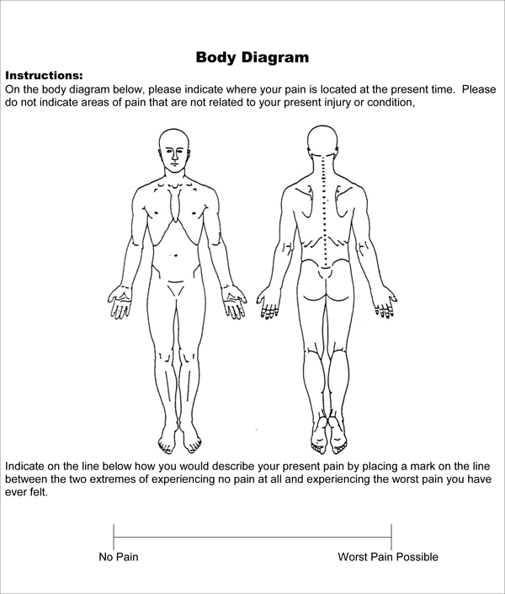 http://img.docstoccdn.com/thumb/orig/33916028.png

Observation of Active Movement (movement analysis):
Scapulohumeral rhythm | Phase 1 | Phase 2 | Phase 3
Humerus | 30° abduction | 40° abduction | 60° abduction, 90° ER
Scapula | minimal | 20° rotation | 30° rotation
Clavicle | 0-5° | 15° elevation | 30-50° post rotation, 15° elevation

1. Ask for elevation of the arm in the scapular plane, describe the following:
Initiation: Sequence:
Compensations: (lateral trunk flexion, scapular elevation…)

2. Observe/describe when and what scapular motion occurs during elevation.

3. Assess motor control in sitting
-Selective movement at shoulder, elbow, wrist against gravity
-FMA UE
PROM :
1.Assess scapular mobility in sitting (on both sides)
Motion | Symmetrical w/uninvolved | Reduced(25-50%) | No Motion
Elevation
Depression
Abduction
Adduction
Upward rotation

2. Assess scapulohumeral rhythm in scapular plane with passive motion of GHJ.
-Describe motion occurring at humerus, scapula and clavicle for each phase.

3. Supine Assessment (performed in scapular plane)
Joint motion/PROM | Uninvolved (R/L) | Involved (R/L) | Other (spasticity, pain)
Shoulder
Scaption (elevation in scapular plane)
External rotation
Internal rotation
Elbow
Wrist
Hand

Joint Mobility (assess for capsular restriction)
-Total GH motion (scapula blocked): _______ (normal=105-120°)
-Posterior glide:
-Anterior glide:
-Seated load and shift:

Soft Tissue Mobility (muscle length and tone)
-Pec major
-Pec minor
-Subscapularis
-Upper trapezius
-Bicep

4. Sidelying Assessment
-Reassess motor control gravity eliminated
-Assess scapular mobility with scapular clock

Assessment:
Diagnostic Impression:
PT Diagnosis:
Prognosis:
Short Term goals (4 weeks):
1.
2.
Long Term goals (8 weeks):
1.
2.
Plan of Care:
PT Interventions:

Referrals:
Education:
Frequency/duration:
Instruction in Home Program:
**Describe in detail specific exercise, position, set up, sets, reps, times/week, etc….
***Must instruct in at least one exercise to address orthopedic restriction and two exercises for motor re-education.

Group Members: _____________________________________________________________________________________
As a group, students present to their class their evaluation and intervention applied during a specified class session. They are asked to ensure that they address all of the areas listed below. Everyone in the group is expected to present at least some portion of the case.
- Brief history: onset, recovery of UE since onset, recent or past therapies for the UE and current use of the UE
- Objective Exam:
- Briefly describe any sensory deficits, cognitive or language deficits
- Describe your observations during their relaxed and upright sitting posture; were there any changes in scapular or spinal alignment?
- Subluxation: describe and relate it to postural alignment described in “b”
- Describe greatest differences between scapular alignment on the involved vs uninvolved and provide at least one measurement as an example
- Movement Analysis
- Show video of elevation or any volitional motion captured in both sagittal and frontal plane
- Discuss initiation, sequence and compensations observed
- Scapulohumeral rhythm
  - Describe scapulohumeral rhythm observed during both passive and active movement
  - Were there differences? Why?
- Motor Control
  - Present findings of either selective motor control assessment or FM-UE
  - Comment on prognosis for recovery of UE function based on your findings and any other factors you consider relevant
- PROM Restrictions
  - Scapular mobility
  - Glenohumeral
- Soft tissue restrictions
- Interventions applied and outcomes
- Briefly describe or demonstrate Home Program
- Comment on your experience
  - Was this easier or more difficult than you anticipated?
  - What was the most difficult assessment to perform?
  - If a patient with an impaired arm due to stroke arrived at the orthopedic clinic you’re working in would you treat him/her or refer out to neurologic clinic?

Time for student to complete the activity: 1 2-hour class time for patient assessment and treatment; 1 2-hour class time for presentations

Readings/other preparatory materials:
- Hardwick, D.D., Lang, C.E. Scapular and Humeral Movement Patterns of People with Stroke during Range-of-Motion Exercises. JNPT 2011;35:18-25
- Peat, M. Functional Anatomy of the Shoulder Complex. PTJ 1986;66:1855-1865.
- Review of orthopedic special tests of the shoulder

Learning Objectives:
- Perform assessment of the shoulder following a stroke, identifying orthopedic impairments and movement dysfunction.
- Develop an intervention plan to address orthopedic impairments and functional limitations related to shoulder.
- Implement an intervention plan to address orthopedic impairments and functional limitations related to shoulder.
- Communicate findings of examination and intervention with classmates in a powerpoint presentation.

Methods of evaluation of student learning:
Criteria | Points possible | Points earned | Comments
SUBJECTIVE (5 points)
Brief history of neurologic event | 1
Course of recovery of UE since onset | 1
Past and current PT or OT for UE | 1
Relevant PMH | 1
Patient Goals | 1
OBJECTIVE (29 points)
Documents results of sensory screen | 1
Documents cognitive and language function | 1
Seated postural assessment includes alignment head, trunk, pelvis, scapula and humerus in frontal and sagittal plane and includes both relaxed an upright posture | 5
Documents degree and direction of subluxation and includes measurement | 2
Draws asymmetries in frontal plane on body diagram including scapular alignment; spinal deformities | 2
Measurement of scapular position is included and asymmetries measured are consistent with observations included above | 3
PROM: scapula  -Estimates reduction in available PROM with comparison to uninvolved  -includes seated and sidelying assessment | 5
PROM: Glenohumeral joint; assessment includes involved and uninvolved and measurements recorded are accurate | 3
Glenohumeral joint mobility: records total GH motion and results of seated load and shift and presence of capsular restriction | 3
Soft Tissue Mobility: records abnormalities in soft tissue for all muscle groups listed | 2
Motor Control: reports values from Fugl-Meyer UE or sidelying synergy assessment | 2
MOVEMENT ANALYSIS (14 points)
Describes initiation and sequence of elevation | 5
Describes all components of scapulohumeral rhythm and estimates contribution of humerus, clavicle and scapula to motion | 5
Describes scapulohumeral rhythm during passive elevation | 2
Describes compensations observed during active motion | 2
ASSESSMENT (11 points)
Diagnostic impression accurately summarizes participation restrictions, activity limitations and impairments related to the UE after a stroke | 3
PT Diagnosis: includes key impairments and links to functional limitations | 2
Prognosis: considers chronicity, recovery to date, personal factors and FMA-UE score | 2
Short Term Goals: Address both orthopedic restrictions and function; measurable; realistic and meaningful | 2
Long Term Goals:  Incorporates patient goals and participation; measurable; realistic and meaningful | 2
PLAN OF CARE (4 points)
Physical Therapy interventions are appropriate to address both orthopedic restrictions and movement re-education | 2
Documents need for referrals and education | 1
Frequency and duration included | 1
INTERVENTIONS APPLIED (9 points)
Home Program addresses orthopedic restrictions and movement re-education; caregiver or family training documented (as indicated). | 3
Orthopedic interventions are described in sufficient detail for replication and include pre and post measurement | 3
Movement re-education is described in sufficient detail for replication and addresses key movement deficits | 3
Case Presentation (10 points)
Clear demonstration of key movement dysfunction with use of SimiMove app | 4
Clearly describes orthopedic restrictions and motor control limitations limiting elevation | 4
All group members actively participate and are prepared | 2
 | Points possible:  82 | Points earned:
Comments:

